Partial / residual correlation: GBPUSD and NZDUSD
Method 07 / daily log returns / leave-currency-out USD factor / Alpari D1 full available history

Study setup
Logical pair: GBPUSD , NZDUSD
Broker symbols: GBPUSD_i , NZDUSD_i
Snapshot: 2026-11-03_majors_alpari_D1
Timeframe: D1
Matched return window: 1999-01-05 to 2026-11-02 (UTC bar dates)
Matched return count n: 7148
Dropped unfinished last bar dated 2026-11-03 UTC after a tick-volume check against the prior complete day.
USD-strength sign rule: minus log return when USD is the quote (EURUSD, GBPUSD, AUDUSD, NZDUSD); plus log return when USD is the base (USDJPY, USDCHF, USDCAD). EURGBP is never a constituent.
Control z constituents (5): EURUSD, AUDUSD, USDJPY, USDCHF, USDCAD
z_t = equal-weight mean of those USD-strength returns on the same day
Complete matched rows (Excel): GBPUSD-NZDUSD_Partial_D1.xlsx
Complete matched rows (HTML table): GBPUSD-NZDUSD_Partial_D1_data.html

Method carried forward
Partial / residual correlation regresses each matched daily log return of close, ln(close_t / close_t-1), on the same leave-currency-out USD strength factor z, then takes Pearson correlation of the two residual series. Quotes are not inverted. z is the equal-weight mean of USD-strength returns from other majors that do not share a non-USD currency with either leg; EURGBP is never a constituent. USD-strength is minus the log return when USD is the quote (EURUSD, GBPUSD, AUDUSD, NZDUSD) and plus the log return when USD is the base (USDJPY, USDCHF, USDCAD). OLS uses an intercept on each leg. rho_partial is symmetric under swap of the two symbols. It describes leftover linear co-movement after removing linear z; it is not a cause, not a lead, and not a trading signal. Daily rows are not independent and residuals are estimated, so the two-sided p-value and Fisher interval are secondary. Same-sample raw Pearson r is a side check only.

Regression on z
leg | intercept_a_or_c | slope_b_or_d | R2
GBPUSD | -2.944e-05 | -0.81413293 | 0.42020015
NZDUSD | 5.08e-06 | -1.2030739 | 0.50061951

Results
rho_partial: 0.136841
Two-sided p-value: 3.18358e-31
Approximate 95% Fisher interval: [0.114020, 0.159518]
Same-sample raw Pearson r: 0.532284
rho_partial minus r: -0.395442

Conclusion
Over 7148 matched daily rows for GBPUSD and NZDUSD after removing a leave-currency-out USD factor built from 5 constituents, rho_partial is 0.1368 (positive, weak residual linear link in this sample). Approximate 95% Fisher interval: [0.1140, 0.1595]. Same-sample raw Pearson r is 0.5323 (partial minus r = -0.3954). Leg R-squared on z: GBPUSD=0.4202, NZDUSD=0.5006. Two-sided p under the usual independent-pairs model is 3.184e-31; residuals are estimated and daily FX rows are linked, so treat p as secondary. This does not establish cause, lead-lag, or a lasting trading rule.

Charts
Daily closes
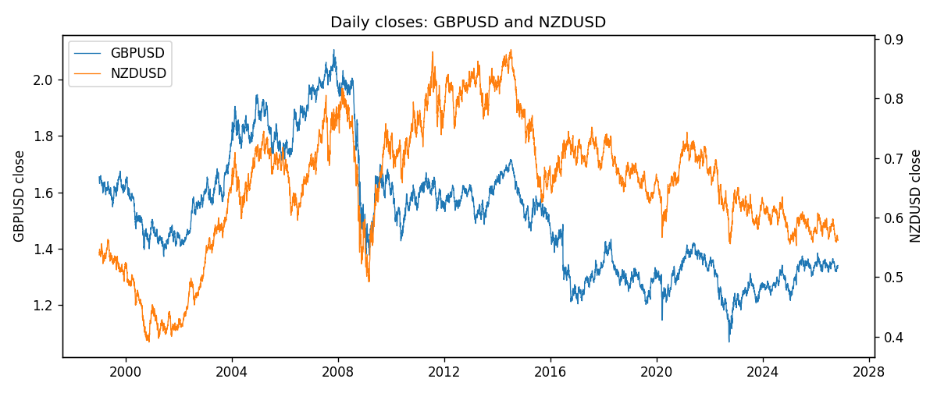
Log returns and control z
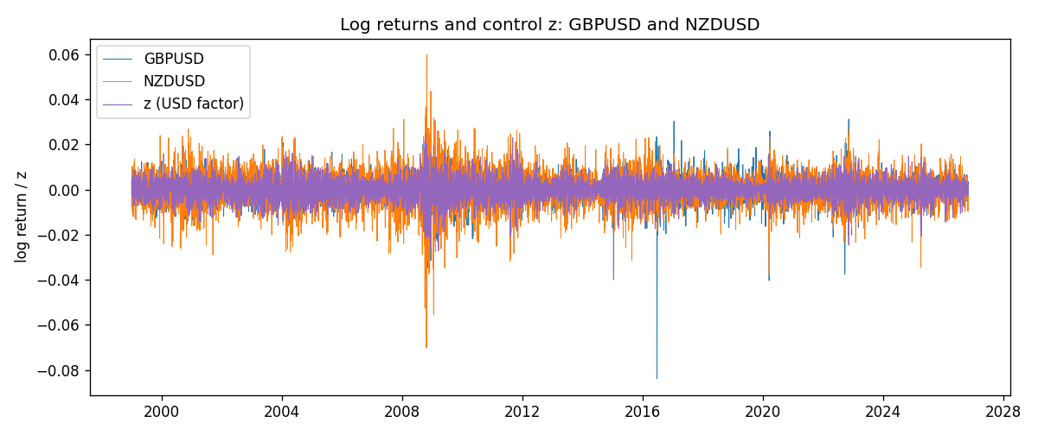
Residual scatter e_x vs e_y
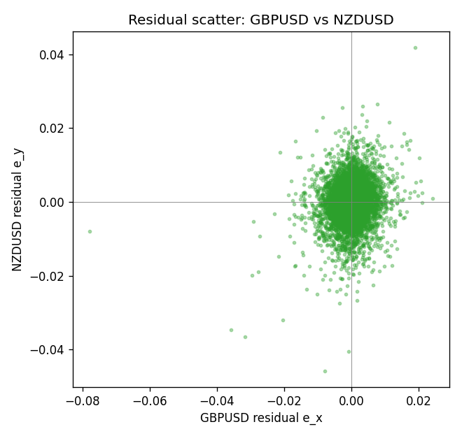

Data report
Every matched row that entered the partial correlation is stored in the sibling Excel workbook named GBPUSD-NZDUSD_Partial_D1.xlsx. That file is the complete data archive for redrawing charts. Embedding all rows as a Word table is impractical at this length; the Word file holds the column list, column summaries, and the first and last 15 matched rows.
Columns: time, GBPUSD_open, NZDUSD_open, GBPUSD_high, NZDUSD_high, GBPUSD_low, NZDUSD_low, GBPUSD_close, NZDUSD_close, GBPUSD_tick_volume, NZDUSD_tick_volume, GBPUSD_spread, NZDUSD_spread, GBPUSD_real_volume, NZDUSD_real_volume, GBPUSD_log_return, NZDUSD_log_return, usd_strength_EURUSD, usd_strength_AUDUSD, usd_strength_USDJPY, usd_strength_USDCHF, usd_strength_USDCAD, z, GBPUSD_fitted, NZDUSD_fitted, GBPUSD_resid, NZDUSD_resid
Column summaries (matched calculation rows)
column | count | mean | std | min | 25% | 50% | 75% | max
GBPUSD_open | 7148 | 1.5147424 | 0.21801364 | 1.06854 | 1.3240425 | 1.50985 | 1.629975 | 2.1066
NZDUSD_open | 7148 | 0.65680048 | 0.1080291 | 0.3913 | 0.5917475 | 0.668695 | 0.72504 | 0.88218
GBPUSD_high | 7148 | 1.5210395 | 0.21858109 | 1.08366 | 1.32902 | 1.516685 | 1.6374625 | 2.1161
NZDUSD_high | 7148 | 0.66072183 | 0.10852081 | 0.3961 | 0.595065 | 0.67222 | 0.729525 | 0.88421
GBPUSD_low | 7148 | 1.5084277 | 0.21724232 | 1.03518 | 1.3186875 | 1.50192 | 1.6233 | 2.0983
NZDUSD_low | 7148 | 0.65311385 | 0.10762321 | 0.3897 | 0.588355 | 0.66451 | 0.72113 | 0.87988
GBPUSD_close | 7148 | 1.5148153 | 0.21797449 | 1.06879 | 1.324035 | 1.50993 | 1.6299575 | 2.1065
NZDUSD_close | 7148 | 0.65687963 | 0.10802405 | 0.3907 | 0.592165 | 0.66876 | 0.72518 | 0.8822
GBPUSD_tick_volume | 7148 | 95468.138 | 153933.58 | 62 | 10088.75 | 53396.5 | 92022.25 | 1273370
NZDUSD_tick_volume | 7148 | 69051.458 | 123370.73 | 17 | 5742 | 34119 | 58667.5 | 1127682
GBPUSD_spread | 7148 | 26.846531 | 19.190643 | 0 | 10.75 | 20 | 50 | 50
NZDUSD_spread | 7148 | 30.128428 | 25.588679 | 0 | 9 | 17 | 40 | 80
GBPUSD_real_volume | 7148 | 3.582457e+09 | 8.4750162e+10 | 0 | 0 | 0 | 0 | 2.4038164e+12
NZDUSD_real_volume | 7148 | 1.678526e+10 | 8.5194876e+10 | 0 | 0 | 0 | 0 | 2.705649e+12
GBPUSD_log_return | 7148 | -1.992e-05 | 0.00564699 | -0.08388241 | -0.0031217 | 3.426e-05 | 0.00318167 | 0.03112653
NZDUSD_log_return | 7148 | 1.914e-05 | 0.00764519 | -0.07027433 | -0.00424201 | 0.00023666 | 0.004586 | 0.05966839
usd_strength_EURUSD | 7148 | 2.16e-06 | 0.0058013 | -0.03433183 | -0.00325609 | -0 | 0.00324218 | 0.03123819
usd_strength_AUDUSD | 7148 | -3.157e-05 | 0.00755018 | -0.0806166 | -0.00415111 | -0.00029168 | 0.00385014 | 0.08602525
usd_strength_USDJPY | 7148 | 5.267e-05 | 0.00620906 | -0.03908203 | -0.00319392 | 0.00012736 | 0.00340928 | 0.05184024
usd_strength_USDCHF | 7148 | -6.945e-05 | 0.0065937 | -0.19545699 | -0.00334697 | 8.15e-05 | 0.00331954 | 0.09051364
usd_strength_USDCAD | 7148 | -1.226e-05 | 0.00514518 | -0.03859748 | -0.00283513 | 4.873e-05 | 0.00272781 | 0.03436319
z | 7148 | -1.169e-05 | 0.00449625 | -0.03996267 | -0.00256173 | 6.273e-05 | 0.00256887 | 0.02463988
GBPUSD_fitted | 7148 | -1.992e-05 | 0.00366054 | -0.02008958 | -0.00212084 | -8.051e-05 | 0.00205615 | 0.03250549
NZDUSD_fitted | 7148 | 1.914e-05 | 0.00540932 | -0.02963852 | -0.00308546 | -7.039e-05 | 0.00308703 | 0.04808312
GBPUSD_resid | 7148 | -0 | 0.00429988 | -0.07781974 | -0.00210784 | 0.00013519 | 0.00229968 | 0.02403817
NZDUSD_resid | 7148 | 0 | 0.00540262 | -0.04576862 | -0.00284973 | 0.00017251 | 0.00300387 | 0.04184519
First 15 matched rows (selected columns)
time | GBPUSD_close | NZDUSD_close | GBPUSD_log_return | NZDUSD_log_return | z | GBPUSD_fitted | NZDUSD_fitted | GBPUSD_resid | NZDUSD_resid
1999-01-05 | 1.6547 | 0.5372 | -0.0028966287 | -0.0018597736 | -0.0001455284 | 8.9041802e-05 | 0.00018015825 | -0.0029856705 | -0.0020399319
1999-01-06 | 1.6537 | 0.5383 | -0.00060452184 | 0.0020455609 | 0.0041105214 | -0.0033759485 | -0.0049401842 | 0.0027714266 | 0.0069857451
1999-01-07 | 1.6502 | 0.5417 | -0.002118709 | 0.0062963171 | -0.0074425693 | 0.0060298031 | 0.0089590379 | -0.0081485121 | -0.0026627208
1999-01-08 | 1.6405 | 0.5414 | -0.0058954193 | -0.00055396548 | 0.0029612798 | -0.0024403131 | -0.0035575617 | -0.0034551062 | 0.0030035962
1999-01-11 | 1.6312 | 0.547 | -0.0056851331 | 0.010290425 | -0.002906195 | 0.0023365914 | 0.0035014442 | -0.0080217245 | 0.006788981
1999-01-12 | 1.6349 | 0.5441 | 0.0022657001 | -0.0053157489 | 0.0058905503 | -0.0048251287 | -0.0070816907 | 0.0070908288 | 0.0017659417
1999-01-13 | 1.6499 | 0.5387 | 0.0091330396 | -0.0099742238 | -0.0017070997 | 0.0013603684 | 0.002058844 | 0.0077726712 | -0.012033068
1999-01-14 | 1.6531 | 0.5386 | 0.0019376331 | -0.00018564931 | 0.0014417803 | -0.0012032385 | -0.0017294915 | 0.0031408715 | 0.0015438421
1999-01-15 | 1.6502 | 0.5382 | -0.0017558204 | -0.00074294208 | 0.0041632394 | -0.003418868 | -0.0050036079 | 0.0016630476 | 0.0042606658
1999-01-18 | 1.6522 | 0.5372 | 0.0012112405 | -0.0018597736 | -0.0013372424 | 0.0010592554 | 0.0016138783 | 0.00015198504 | -0.0034736519
1999-01-19 | 1.6553 | 0.5382 | 0.0018745281 | 0.0018597736 | -0.0019992215 | 0.0015981944 | 0.002410288 | 0.00027633378 | -0.00055051438
1999-01-20 | 1.6472 | 0.5404 | -0.0049053846 | 0.0040793678 | -0.00043670987 | 0.00032610222 | 0.00053047108 | -0.0052314868 | 0.0035488967
1999-01-21 | 1.6524 | 0.5426 | 0.0031518998 | 0.0040627941 | -0.00068834588 | 0.00053096739 | 0.00083320781 | 0.0026209324 | 0.0032295863
1999-01-22 | 1.6565 | 0.5361 | 0.0024781662 | -0.012051689 | 0.0043725466 | -0.0035892719 | -0.00525542 | 0.0060674381 | -0.0067962694
1999-01-25 | 1.6585 | 0.5342 | 0.0012066366 | -0.0035504102 | 0.0005870848 | -0.00050740273 | -0.00070122958 | 0.0017140394 | -0.0028491806
Last 15 matched rows (selected columns)
time | GBPUSD_close | NZDUSD_close | GBPUSD_log_return | NZDUSD_log_return | z | GBPUSD_fitted | NZDUSD_fitted | GBPUSD_resid | NZDUSD_resid
2026-10-13 | 1.32534 | 0.56127 | 0.0036434319 | 0.0047326165 | -0.0032538954 | 0.0026196657 | 0.0039197535 | 0.0010237662 | 0.00081286302
2026-10-14 | 1.31884 | 0.55918 | -0.0049164679 | -0.0037306483 | 0.0019621309 | -0.0016268731 | -0.0023555117 | -0.0032895949 | -0.0013751365
2026-10-15 | 1.32757 | 0.56185 | 0.0065976411 | 0.0047634855 | -0.0026617438 | 0.0021375756 | 0.0032073514 | 0.0044600655 | 0.0015561341
2026-10-16 | 1.33257 | 0.56509 | 0.0037592051 | 0.0057501001 | -0.0025196362 | 0.0020218811 | 0.0030363854 | 0.001737324 | 0.0027137147
2026-10-19 | 1.33024 | 0.56616 | -0.0017500314 | 0.0018917133 | 0.00053995872 | -0.00046903584 | -0.00064453343 | -0.0012809956 | 0.0025362467
2026-10-20 | 1.3377 | 0.56827 | 0.0055923442 | 0.0037199341 | -0.0028879195 | 0.0023217127 | 0.0034794574 | 0.0032706316 | 0.00024047669
2026-10-21 | 1.33937 | 0.57003 | 0.0012476328 | 0.0030923331 | -0.00097243966 | 0.00076225748 | 0.0011749936 | 0.00048537535 | 0.0019173395
2026-10-22 | 1.33967 | 0.56815 | 0.00022396082 | -0.0033035227 | -0.0026332831 | 0.0021144048 | 0.003173111 | -0.001890444 | -0.0064766337
2026-10-23 | 1.33684 | 0.56991 | -0.0021146949 | 0.0030929853 | 0.00099876568 | -0.00084256569 | -0.0011965121 | -0.0012721292 | 0.0042894974
2026-10-26 | 1.33359 | 0.56826 | -0.0024340661 | -0.0028993932 | 0.0022991432 | -0.0019012458 | -0.0027609624 | -0.00053282029 | -0.00013843078
2026-10-27 | 1.33044 | 0.56811 | -0.0023648393 | -0.00026399852 | 0.0020797037 | -0.0017225929 | -0.0024969605 | -0.00064224641 | 0.0022329619
2026-10-28 | 1.33254 | 0.56261 | 0.0015771808 | -0.0097283914 | -0.0024253561 | 0.0019451246 | 0.0029229595 | -0.00036794386 | -0.012651351
2026-10-29 | 1.33733 | 0.56296 | 0.0035881935 | 0.00062190714 | -0.00070568005 | 0.0005450797 | 0.00085406209 | 0.0030431138 | -0.00023215495
2026-10-30 | 1.33913 | 0.56307 | 0.0013450605 | 0.00019537668 | -0.00024759382 | 0.00017213662 | 0.0003029505 | 0.0011729238 | -0.00010757382
2026-11-02 | 1.3406 | 0.56161 | 0.0010971256 | -0.0025962955 | -0.00021780039 | 0.00014788081 | 0.0002671068 | 0.00094924476 | -0.0028634023

